
Area name here
Norfolk


Annual Report
Introduction

MAPPA TRAINING

Information Sharing is vital to ensure the MAPPA process works effectively and all Responsible Authorities and Duty to Cooperate Agencies need to be aware of their MAPPA duties under the Criminal Justice Act 2003.
To ensure all local agencies and partnerships are kept up to date, this year Norfolk held two training events at Wymondham Rugby Club. The events were attended by 165 agency professionals from across Norfolk. The feedback was excellent. These events have led to greater attendance at MAPPA meetings by all agencies.
Norfolk MAPPA aim to run these events twice yearly to maintain excellent working relationships and multi-agency working to ensure robust risk management of all MAPPA nominals the next event is planned for 16th October 2019.
MAPPA WEBSITE

The Norfolk MAPPA website has been revamped to make it easier for anyone to access and gain information. Partners have been asked to provide a hyperlink to their own organisations in order to provide valuable information to assist in safeguarding. www.norfolkmappa.org.uk An evaluation into the usefulness will be carried out after twelve months.
ACCOMMODATION FOR MAPPA OFFENDERS

MAPPA offenders are very difficult to house, particularly those with sexual offence or arson convictions. Here is a good news story which has morphed into an exciting new project.
A 51 year old man convicted of serious sexual offences and sentenced to 12 years in prison was due to be released. The offender’s high risk and mental Health made him a MAPPA candidate.
The multi-disciplinary meeting put safeguards in place but having secured an Approved Premises for a twelve-week period move on accommodation seemed impossible to secure. He was robustly managed by Probation and responded well to the new regimes, help and support. At a subsequent meeting St Martins Housing Trust knowing all the risks having attended all previous meetings offered a bed at one of their Hostels which was accepted. He worked well with the housing keyworker and the results from the programs attended were positive including compliance with all restrictions.
This resulted in him securing further temporary accommodation whilst agencies assisted in securing independent housing. Having learnt lessons from this case an exciting collaborative idea was born.
Housing is such a crucial stabilizer in managing risk and as such MAPPA have secured partnership funding to recruit a Housing Officer part time with direct responsibility to find offenders accommodation and build a network of suitable engaged housing providers prepared to take on tenants who pose a risk. This will be done in partnership with St Martins Housing Trust and Broadland Council Housing. A robust review of the effectiveness of the post will be completed after twelve months.
MAPPA Coordinator, Norfolk

What is MAPPA?

MAPPA background
MAPPA (Multi-Agency Public Protection Arrangements) are a set of arrangements to manage the risk posed by the most serious sexual and violent offenders (MAPPA-eligible offenders) under the provisions of sections 325 to 327B of the Criminal Justice Act 2003.
They bring together the Police, Probation and Prison Services in each of the 42 Areas in England and Wales into what is known as the MAPPA Responsible Authority.
A number of other agencies are under a Duty to Co-operate (DTC) with the Responsible Authority. These include Social Services, Health Services, Youth Offending Teams, Jobcentre Plus and Local Housing and Education Authorities.
The Responsible Authority is required to appoint two Lay Advisers to sit on each MAPPA area Strategic Management Board (SMB) alongside senior representatives from each of the Responsible Authority and DTC agencies.
Lay Advisers are members of the public appointed by the Minister with no links to the business of managing MAPPA offenders who act as independent, yet informed, observers; able to pose questions which the professionals closely involved in the work might not think of asking. They also bring to the SMB their understanding and perspective of the local community (where they must reside and have strong links).
How MAPPA works
MAPPA-eligible offenders are identified and information about them is shared between agencies to inform the risk assessments and risk management plans of those managing or supervising them.
That is as far as MAPPA extend in the majority of cases, but some cases require structured multi-agency management. In such cases there will be regular MAPPA meetings attended by relevant agency practitioners.
There are 3 categories of MAPPA-eligible offender:
- Category 1 - registered sexual offenders;
- Category 2 – mainly violent offenders sentenced to 12 months or more imprisonment or a hospital order; and
- Category 3 – offenders who do not qualify under categories 1 or 2 but who currently pose a risk of serious harm.
There are three levels of management to ensure that resources are focused where they are most needed; generally those presenting the higher risks of serious harm.
- Level 1 is where the offender is managed by the lead agency with information exchange and multi-agency support as required but without formal MAPPA meetings;
- Level 2 is where formal MAPPA meetings are required to manage the offender.
- Level 3 is where risk management plans require the attendance and commitment of resources at a senior level at MAPPA meetings.
MAPPA are supported by ViSOR. This is a national IT system to assist in the management of offenders who pose a serious risk of harm to the public. The use of ViSOR increases the ability to share intelligence across organisations and enable the safe transfer of key information when high risk offenders move, enhancing public protection measures. ViSOR allows staff from the Police, Probation and Prison Services to work on the same IT system for the first time, improving the quality and timeliness of risk assessments and interventions to prevent offending.
All MAPPA reports from England and Wales are published online at: www.gov.uk

MAPPA Statistics

MAPPA-eligible offenders on 31 March 2019
 | Category 1:  Registered sex  offenders | Category 2:  Violent  offenders | Category 3:  Other dangerous  offenders | Total
Level 1 | 1094 | 462 | - | 1556
Level 2 | 5 | 1 | 7 | 13
Level 3 | 0 | 1 | 0 | 1
Total | 1099 | 464 | 7 | 1570

MAPPA-eligible offenders in Levels 2 and 3 by category (yearly total)
 | Category 1:  Registered sex  offenders | Category 2:  Violent  offenders | Category 3:  Other dangerous  offenders | Total
Level 2 | 33 | 38 | 52 | 123
Level 3 | 0 | 1 | 2 | 3
Total | 33 | 39 | 54 | 126

RSOs cautioned or convicted for breach of notification requirements | 13

RSOs who have had their life time notification revoked on application | 11

Restrictive orders for Category 1 offenders
SHPOs, SHPOs with foreign travel restriction & NOs imposed by the courts
SHPO | 85
SHPO with foreign travel restriction | 0
NOs | 3

Number of people who became subject to notification requirements following a breach(es) of a Sexual Risk Order (SRO) | 2

Level 2 and 3 offenders returned to custody
 | Category 1:  Registered sex  offenders | Category 2:  Violent  offenders | Category 3:  Other dangerous  offenders | Total
Breach of licence
Level 2 | 6 | 14 | 16 | 36
Level 3 | 1 | 3 | 2 | 6
Total | 7 | 17 | 18 | 42
Breach of SOPO
Level 2 | 0 | - | - | 0
Level 3 | 0 | - | - | 0
Total | 0 | - | - | 0

Total number of Registered Sexual Offenders per 100,000 population | 136

This figure has been calculated using the mid-2018 estimated resident population, published by the Office for National Statistics on 26 June 2019, excluding those aged less than ten years of age.

Explanation commentary on statistical tables

MAPPA background
The totals of MAPPA-eligible offenders, broken down by category, reflect the picture on 31 March 2019 (i.e. they are a snapshot). The rest of the data covers the period 1 April 2018 to 31 March 2019.
(a) MAPPA-eligible offenders – there are a number of offenders defined in law as eligible for MAPPA management, because they have committed specified sexual and violent offences or they currently pose a risk of serious harm, although the majority are actually managed at Level 1 without formal MAPPA meetings. These figures only include those MAPPA eligible offenders living in the community. They do not include those in prison or detained under the Mental Health Act.
(b) Registered Sexual Offenders (RSOs) – those who are required to notify the police of their name, address and other personal details and to notify of any subsequent changes (this is known as the “notification requirement.”) These offenders are assessed and managed by the police. They may also be managed by probation or health services if they are subject to licence or a hospital order. Failure to comply with the notification requirement is a criminal offence that carries a maximum penalty of 5 years’ imprisonment.
(c) Violent Offenders – this category includes violent offenders sentenced to imprisonment or detention for 12 months or more, or detained under a hospital order. It also includes a small number of sexual offenders who do not qualify for registration. These offenders are assessed and managed by the National Probation Service, Youth Offending Team or Mental Health Services.
(d) Other Dangerous Offenders – offenders who do not qualify under the other two MAPPA-eligible categories, but who currently pose a risk of serious harm which requires management via MAPPA meetings. These offenders are assessed and managed by whichever agency has the primary responsibility for them.
(e) Breach of licence – offenders released into the community following a period of imprisonment will be subject to a licence with conditions (under probation supervision). If these conditions are not complied with, breach action will be taken and the offender may be recalled to prison.
(f) Sexual Harm Prevention Order (SHPO) (including any additional foreign travel restriction). Sexual Harm Prevention Orders (SHPOs) and interim SHPOs replaced Sexual Offence Prevention Orders. They are intended to protect the public from offenders convicted of a sexual or violent offence who pose a risk of sexual harm to the public by placing restrictions on their behaviour. They requires the offender to notify their details to the police (as set out in Part 2 of the 2003 Act) for the duration of the order.
The court must be satisfied that an order is necessary to protect the public (or any particular members of the public) in the UK, or children or vulnerable adults (or any particular children or vulnerable adults) abroad, from sexual harm from the offender. In the case of an order made on a free standing application by a chief officer or the National Crime Agency (NCA), the chief officer/NCA must be able to show that the offender has acted in such a way since their conviction as to make the order necessary.
The minimum duration for a full order is five years. The lower age limit is 10, which is the age of criminal responsibility, but where the defendant is under the age of 18 an application for an order should only be considered exceptionally.
(g) Notification Order – this requires sexual offenders who have been convicted overseas to register with the police, in order to protect the public in the UK from the risks that they pose. The police may apply to the court for a notification order in relation to offenders who are already in the UK or are intending to come to the UK.
(h) Sexual Risk Order (including any additional foreign travel restriction)
The Sexual Risk Order (SRO) replaced the Risk of Sexual Harm Order (RoSHO) and may be made in relation to a person without a conviction for a sexual or violent offence (or any other offence), but who poses a risk of sexual harm.

The SRO may be made at the magistrates’ court on application by the police or NCA where an individual has committed an act of a sexual nature and the court is satisfied that the person poses a risk of harm to the public in the UK or children or vulnerable adults overseas.

A SRO may prohibit the person from doing anything described in it, including travel overseas. Any prohibition must be necessary to protect the public in the UK from sexual harm or, in relation to foreign travel, protecting children or vulnerable adults from sexual harm.

An individual subject to an SRO is required to notify the police of their name and home address within three days of the order being made and also to notify any changes to this information within three days.
A SRO can last for a minimum of two years and has no maximum duration, with the exception of any foreign travel restrictions which, if applicable, last for a maximum of five years (but may be renewed).

The criminal standard of proof continues to apply. The person concerned is able to appeal against the making of the order and the police or the person concerned are able to apply for the order to be varied, renewed or discharged.

A breach of a SRO is a criminal offence punishable by a maximum of five years’ imprisonment. Where an individual breaches their SRO, they will become subject to full notification requirements.

Individuals made subject of a SRO are now recorded on VISOR as a Potentially Dangerous Person (PDP).

(i) Lifetime notification requirements revoked on application
A legal challenge in 2010 and a corresponding legislative response means there is now a mechanism in place that allows qualifying sex offenders to apply for a review of their notification requirements. Persons do not come off the register automatically. Qualifying offenders may submit an application to the police to review their indefinite notification requirements. The police review the application and decide whether to revoke the notification requirements. This decision is made at the rank of Superintendent. Those who continue to pose a significant risk will remain on the register for life, if necessary.

Individuals will only become eligible to seek a review once they have been subject to indefinite notification requirements for a period of at least 15 years for adults and 8 years for juveniles. This applied from 1 September 2012 for adult offenders.

Norfolk Update

I am the Detective Inspector that has responsibility for MAPPA on behalf of Norfolk Constabulary, and a peer Inspector on the Specialist Child Protection Inspection Team for Her Majesty’s Inspectorate of Constabulary and Fire and Rescue Services (HMICFRS). As part of my role for HMICFRS I conduct reviews on other Forces and their MAPPA processes, so I am able to compare with our own processes.
Norfolk MAPPA is a very well-run department, with good co-operation between the agencies. There has historically been issues with some agencies, who were not fully engaged with the process. However, the current Norfolk Chair, has approached this issue, and escalated it to a senior level, which has resulted in consistent attendance at the meetings. This has enabled more robust safeguarding to be completed at the meetings, rather than waiting for agencies to complete it outside. The meetings continue to run well and in a timely fashion despite the additional partners being present. I feel that Norfolk is on par with the best MAPPA’s that I have Inspected from other areas in the Country, which is a credit to the work and improvements that the current chair has implemented.
DI, PPU, Norfolk Constabulary
It has been a few years since I was appointed as one of the Norfolk MAPPA Lay Advisers. During this time I have both enjoyed and found valuable the opportunity to take part in MAPPA meetings and positively influence the delivery of MAPPA in Norfolk.
Since the last annual report, it is ever more apparent that the success of MAPPA pivots on the strong, co-ordinated, multi-agency approach to ensure offender risk is managed properly in society, and that the established community are protected correctly.
Success hinges on the partnership having a strong capable coordination function. It is due to this that people in the County remain better protected.
Lay Adviser
Attending the Strategic Management Board has given me better insight and understanding of how other agencies operate and create contacts to use in normal day to day business to answer questions and provide support to those that need it.
Universal Credit Work Services Manager

All MAPPA reports from England and Wales are published online at:
www.gov.uk

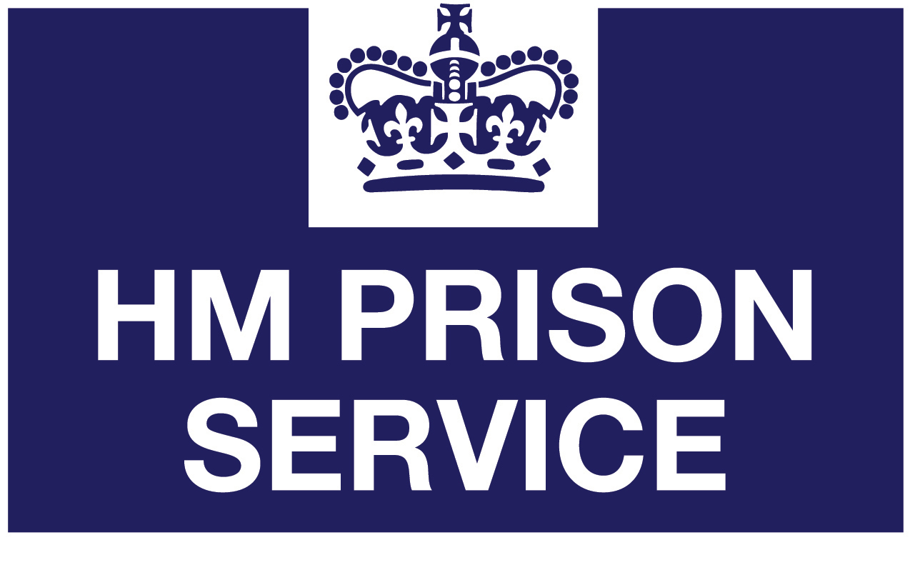

 |  | 

